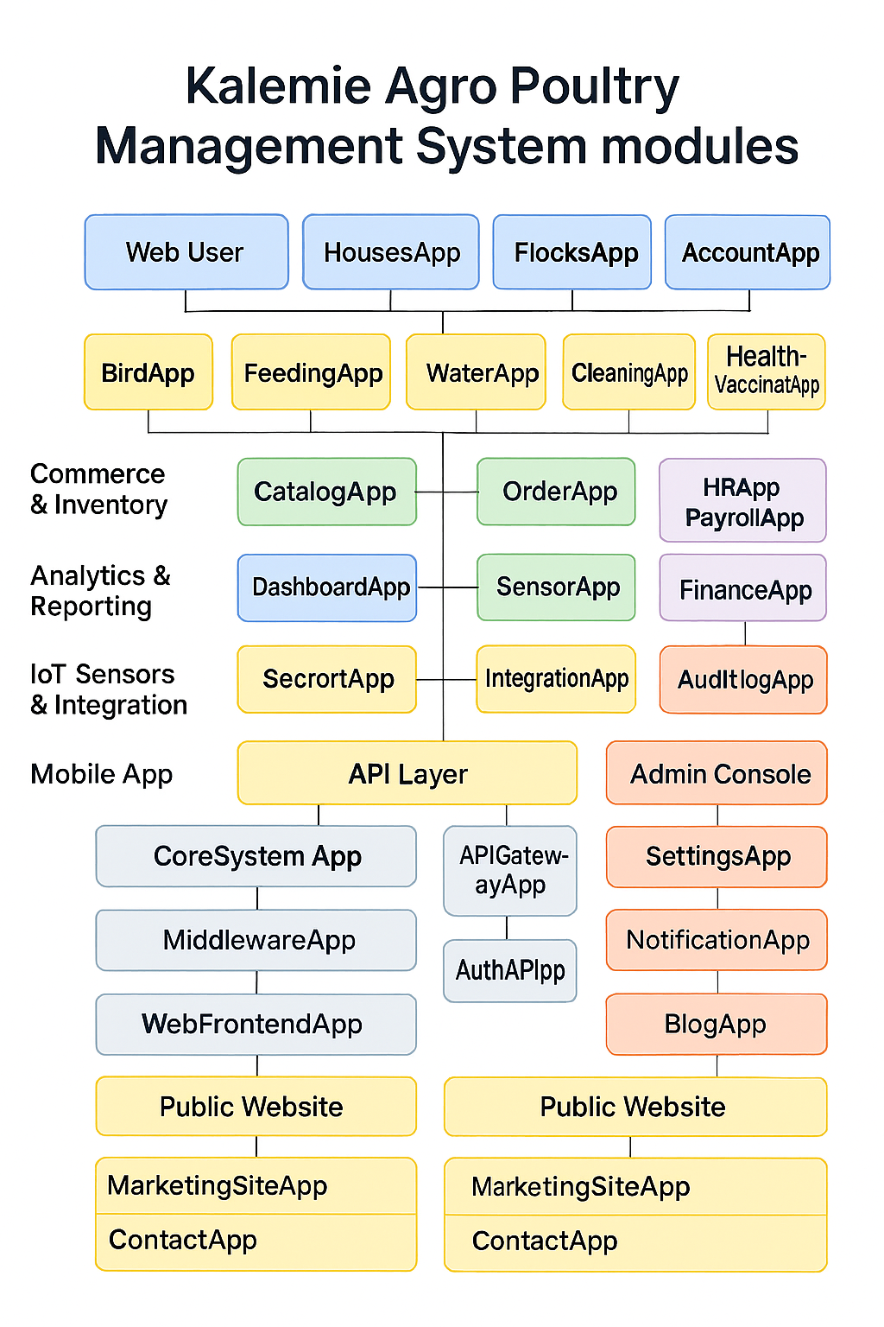 Based on your current system architecture for the **Kalemie Agro Poultry Management System**, here’s a breakdown of the **total number of modules and apps**:

**✅ Total Modules: 12**

1. **Infrastructure & Control**
2. **Operations**
3. **Commerce & Inventory**
4. **HR & Finance**
5. **Analytics & Reporting**
6. **IoT Sensors & Integration**
7. **Mobile App**
8. **Admin Console**
9. **API Layer**
10. **Core System Components**
11. **Web App**
12. **Public Website**

**🧩 Estimated Total Django Apps (Grouped by Module)**

**Kalemie Agro Poultry Management System “**

**A modular, scalable, and multilingual poultry farm management system built with Django. Supports IoT integration, mobile access, and real-time analytics.**

| **Module** | **Apps** |
| --- | --- |
| **Infrastructure & Control** | FarmApp, HousesApp, FlocksApp, SectorApp, AccountApp *(5 apps)* |
| **Operations** | BirdApp, FeedingApp, WaterApp, CleaningApp, HealthVaccinationApp, EggCollectionApp, ProcessingApp *(7 apps)* |
| **Commerce & Inventory** | CatalogApp, InventoryApp, OrderApp, CustomerApp, SupplierApp, ShoppingCartApp, SalesApp *(7 apps)* |
| **HR & Finance** | HRApp, PayrollApp, FinanceApp *(3 apps)* |
| **Analytics & Reporting** | DashboardApp, ReportApp *(2 apps)* |
| **IoT Sensors & Integration** | SensorApp, IntegrationApp *(2 apps)* |
| **Mobile App** | MobileFrontendApp, MobileAPIApp *(2 apps)* |
| **Admin Console** | SettingsApp, NotificationApp, AuditLogApp *(3 apps)* |
| **API Layer** | APIGatewayApp, AuthAPIApp *(2 apps)* |
| **Core System Components** | CoreApp, RBACApp, MiddlewareApp *(3 apps)* |
| **Web App** | WebFrontendApp, UserPortalApp *(2 apps)* |
| **Public Website** | MarketingSiteApp, ContactApp, BlogApp *(3 apps) “* |

**📊 Total Estimated Django Apps: ~41**

This number may vary slightly depending on how you modularize shared components or utilities.

Would you like a **visual map** of all modules and apps, or a **spreadsheet** listing them with responsibilities and dependencies?